Flight Data Recorder (FDR)

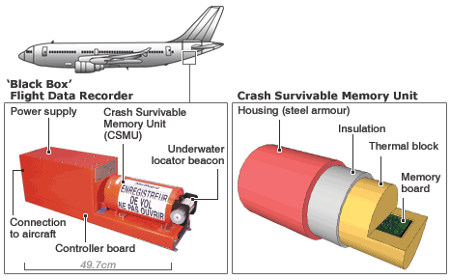

<https://says.com/my/lifestyle/facts-and-information-about-black-boxes-or-fdr>

CSMU

What are they made of? The crash-survivable memory units (CSMUs) of the FDRs and cockpit voice recorders have an aluminium housing, high-temperature insulation and stainless-steel shell

<https://www.edn.com/electronics-blogs/all-aboard-/4429492/Secrets-inside-an-airplane-s-black-box>

